If then statement

If this happens = do this

otherwise = do that

if [ condition ]

then # the condition satisifies print the below statement

echo statement

else # condition not satisifies print the below statement

echo statement

fi

1. create a file and edit that file command is **vi file_name**



**Then press enter**

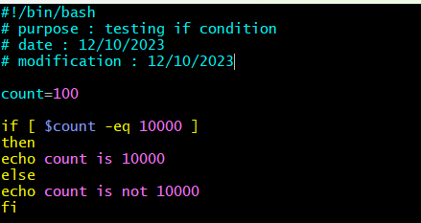

Change the permissions to execute the file



Execute the file command is **bash file_name or ./file_name**



Again change the script in file and executed, again go to edit the file using **vi file_name**

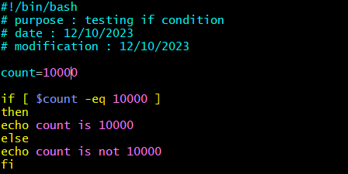

And execute the file



1. to check whether the file is there or not in my directory

create a file and edit that file with command **vi file_name**

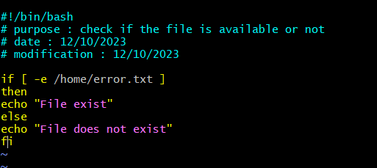

And change the permissions use command **chmod 755 file_name**



Execute the file command is **bash file_name**



Again edit the file and give the correct path, to edit use **vi file_name**

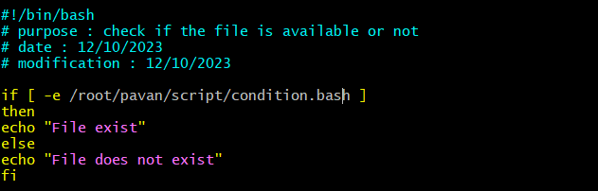

Execute the file and it shows file exist.. command for execute : **bash file_name**



1. check if a variable value is met or not

create and edit a file with the command **vi file_name**

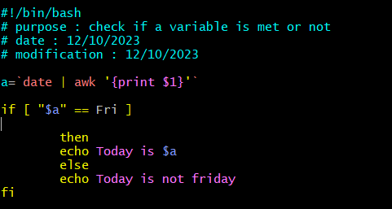

Change the permissions to this file use command **chmod 755 file_name**



Execute the file with the command **bash file_name**



**Suppose today is Thursday then print today is Thursday**

**Then write scripting as follows**

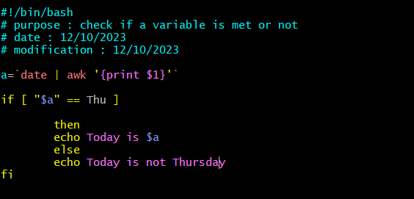



1. **Check the response and then output**

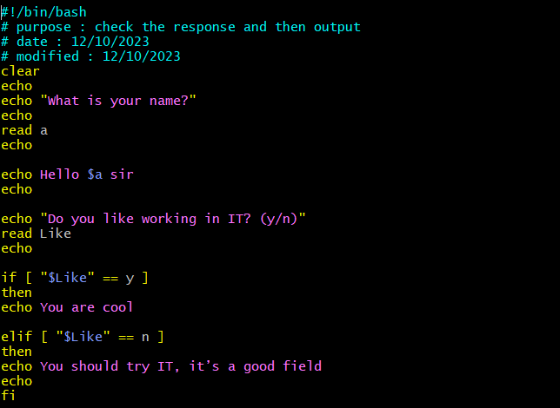

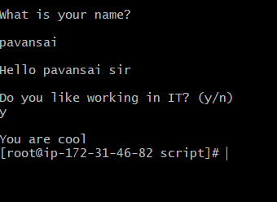

**If we give no to this execution,**

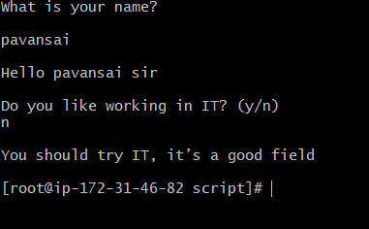

1. **Case statement script**

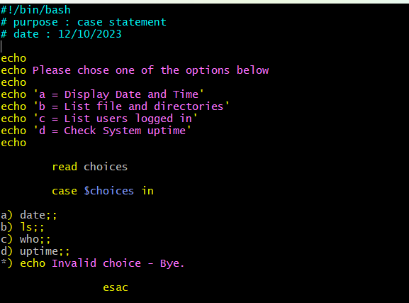

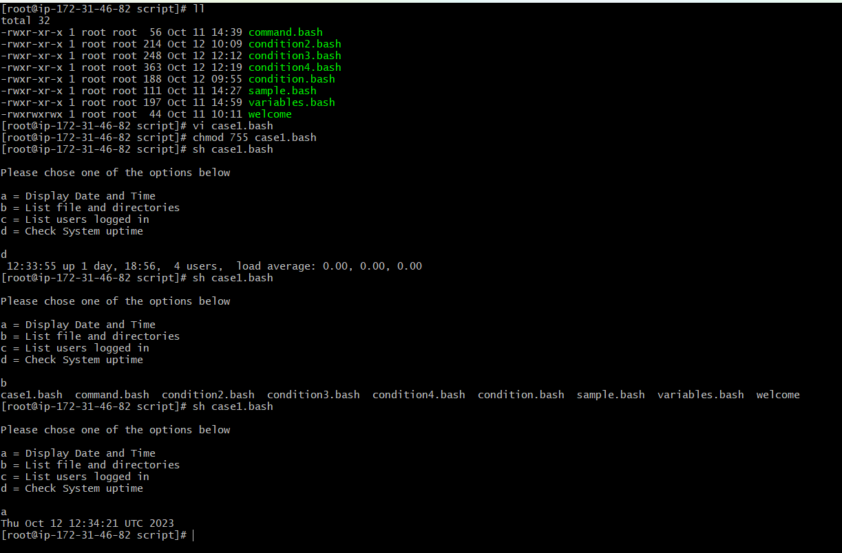

1. **This script will look at your current day and tell you the state of the backup**

First create a file and edit that file

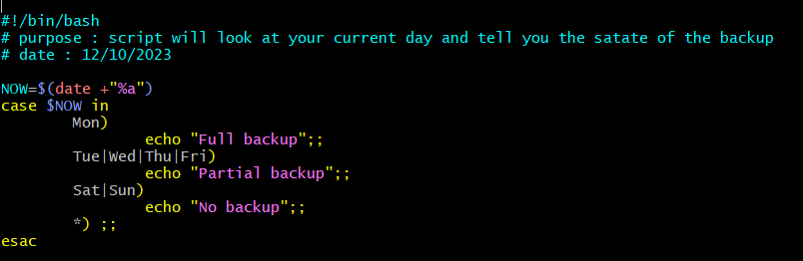

Change the permissions and execute



**7) using for loop to run the script 5 times**

**First create and edit a file**

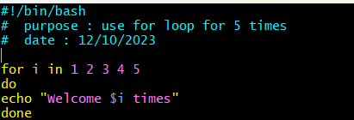

**Then change the permissions and execute**

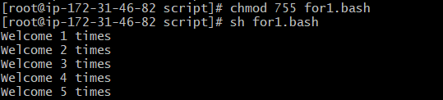

**8) using for loop to print varible**

**Create and edit the file**

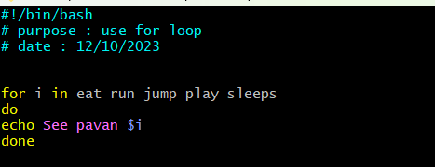

**Change permissions and execute the file**



**9) for loop to create 5 files named 1-5**

Create file and edit the file

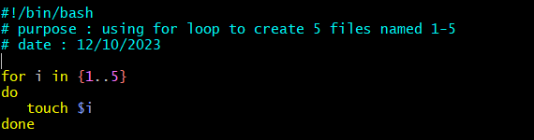

Change permisssions and execute



10) **for loop to delete 5 files named 1-5**

Create and edit the file

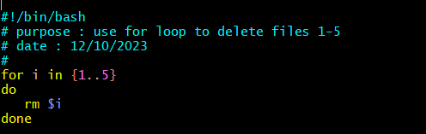

**Change permissions and execute**

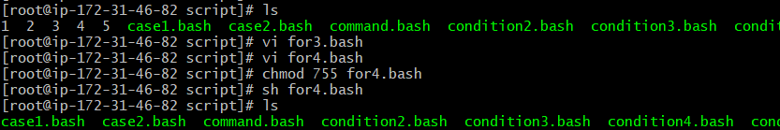

**11) Specify days in for loop**

Create a file and edit that one

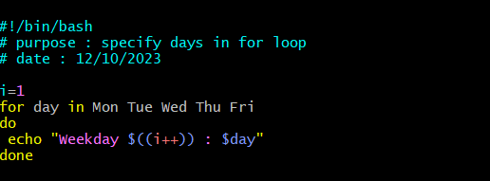

Change the permissions and execute

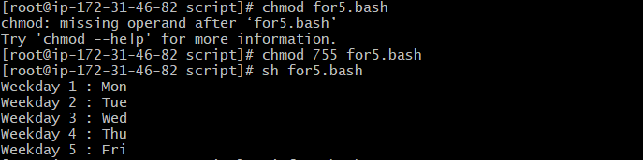

12) **List all users one by one from /etc/passwd file**

Create a file and edit that file

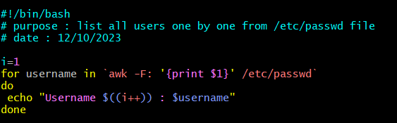

Change permissions and execute

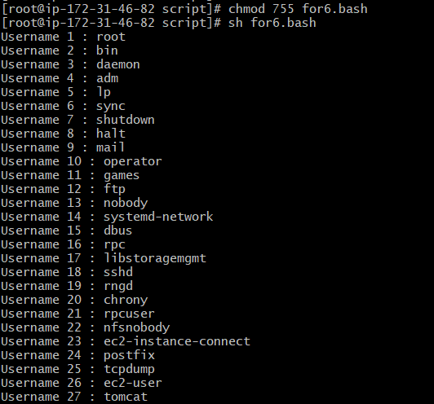

**Do-while Scripts:**

**13) stop the process sec by sec using do while**

**Create a file and edit that file**

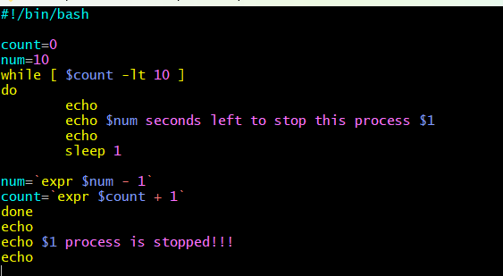

**Change the permissions and execute**

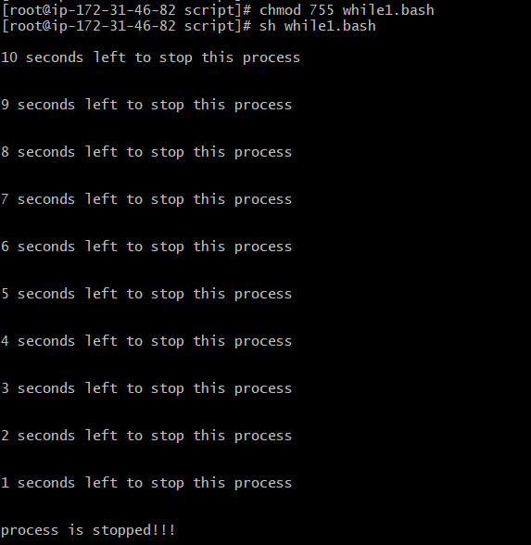

**14) Script to run for a number of times**

**Create a file and edit**

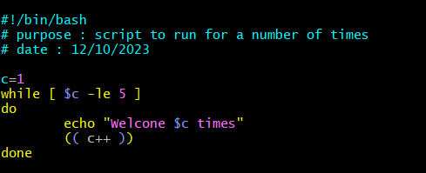

Change the permission and execute

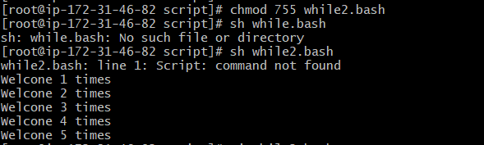

Exit status

15) Return Successful Exist Status

Create a file and edite

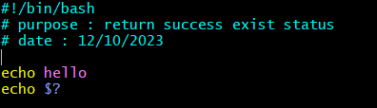

Change the permissions and execute

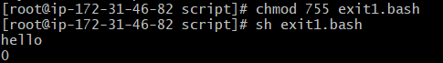

*) 0 = ok or successful

*) 1 = Minor problem

*) 2 = serious problem

*) 3-255 = Everything else

16) Return Un-Successful Exist Status

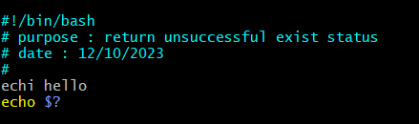



17) Return exist status if file exist

Create a file and edit the file in file give the right path existing in our directory

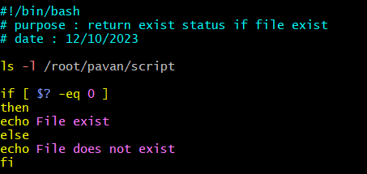

Change permissions and execute

